Message 1: Be Your Best Self

Email subject: Take advantage of your free Firstbeat Lifestyle Assessment

Firstbeat and Your company name are offering you the chance to give your daily life the boost it deserves with the Firstbeat Lifestyle Assessment!

Try the simple assessment that reveals what causes you stress, what helps you recover, and the health and fitness benefits of exercise.

And it couldn’t be easier. A 3-day Heart Rate Variability measurement gives an accurate and reliable picture of your well-being as you go about your normal day. The results? Insights that help you reach your full potential.

Please note, the Lifestyle Assessment results are for your eyes only – your employer will not see your personal results at any stage. Read more about data processing in our Privacy Policy.

Discover what works for you

Do you sometimes feel stressed out? Or wake up tired even after a long night’s sleep? Maybe you’re just looking for more relaxation and recovery in your day? The Firstbeat Lifestyle Assessment helps you pinpoint what does (and doesn’t) work for you to help improve your daily life.

- Learn how to manage and utilise stress – goodbye future burn-out!
- Find easy ways to re-charge your batteries – gain energy for work and leisure time!
- Get to know your Fitness Level and re-ignite your passion for exercise that suits you!

What happens next?
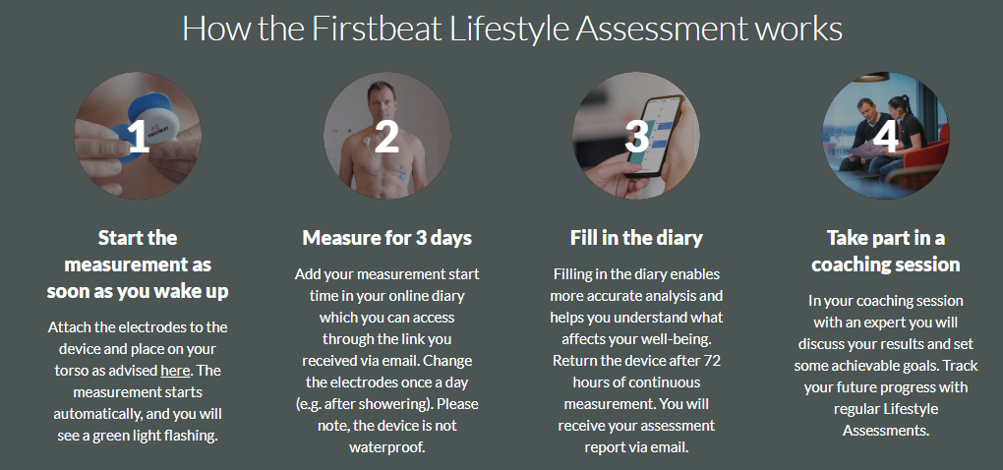

- Lifestyle Assessment timeline:
- The kick-off meeting timetable:
For more information, go to: https://www.firstbeat.com/en/your-best-self/
Should you have any questions, don’t hesitate to contact us directly support@firstbeat.com. We’re here to help!

